
FACULTY OF ENGINEERING
DEGREE ENGINEERING
DEPARTMENT OF COMPUTER ENGINEERING
SOFTWARE ENGINEERING (BE103505)
Unit-1 –Introduction to Software and Software Engineering

(1) Software & Software Engineering

What is Software?
Software is a collection of programs, data, and documentation that helps a computer perform specific tasks.
It includes:
- Programs that run on a computer.
- Data and content used while the program is running.
- Documentation (user manuals, guides, reports, etc.) in printed or digital form. .

Characteristics of Software

1. Software is Developed, Not Manufactured

Meaning:
- Software is designed and developed by programmers.
- It is not manufactured like hardware products (mobile phones, keyboards, etc.).
- Hardware is first designed and then produced in factories.
- Software is created by writing code, testing it, and improving it.
- The quality of software depends mainly on good design and coding.

Example:
- Microsoft Word is developed by programmers.
- A laptop is manufactured in a factory.

2. Software Does Not Wear Out

Meaning:
- Hardware becomes old and damaged over time.
- Software does not become physically damaged because it has no physical parts.

Hardware wears out because of:
- Dust
- Heat
- Water
- Physical damage
- Aging

Software:
- It does not wear out physically.
- Problems happen because of:
  - Bugs (errors)
  - Poor design
  - Changes in requirements
  - Improper maintenance

Example:
- A keyboard may stop working after years of use.
- A software application may fail because of a programming error, not because it became old.

3. Most Software is Custom-Built

Meaning:
- Most software is made according to the customer's needs.
- Some parts (components) can be reused in different software projects.

Example:
- Login systems
- Payment gateways
- Database modules
These can be reused in many different applications.

Quick Revision Table
Characteristic | Easy Meaning
Software is developed, not manufactured. | Software is created by coding, not made in factories.
Software does not wear out. | It does not become old physically but may have bugs or need updates.
Most software is custom-built. | Software is usually made for specific needs, but reusable components save time.

Software Myths

(2)What are Software Myths?
Software myths are false beliefs or misunderstandings about software and the process of developing it.
There are three types of software myths:
- Management Myths
- Customer Myths
- Practitioner's Myths

1. Management Myths

Myth 1:
"We already have a book of software standards and procedures. That's all the developers need."

Reality:
- Having a book is not enough.
- Developers must know about it and actually use it.
- The book should be updated with modern software engineering practices.
- In many companies, the book is outdated or ignored.
A standards book is useful only if it is updated and properly followed.

Myth 2:
"If the project is running late, we can simply hire more programmers."

Reality:
- Software development is different from manufacturing.
- New programmers need training.
- Existing team members spend time teaching them instead of coding.
- This can slow down the project at first.
- New people should be added only with proper planning.
Adding more programmers does not always make the project finish faster.

Myth 3:
"If we outsource the project, we don't have to worry anymore."

Reality:
- Outsourcing does not remove your responsibility.
- The company must still monitor and manage the project.
- Poor project management will still cause problems.
Even after outsourcing, project management is still necessary.

2. Customer Myths

Myth 1:
"We can give only general requirements now and provide details later."

Reality:
- Unclear requirements create confusion.
- Developers need clear and complete requirements.
- Good communication between the customer and developer is essential.
Clear requirements are necessary for a successful project.

Myth 2:
"Software is flexible, so changing requirements is always easy."

Reality:
- Requirements can change.
- Early changes are easy and inexpensive.
- Late changes increase cost, time, and effort.
- They may require redesigning and rewriting code.
The later the change, the higher the cost.

3. Practitioner's Myths

Myth 1:
"Once the program works, our job is finished."

Reality:
- Software needs maintenance after delivery.
- Bugs must be fixed.
- New features may be added.
- Around 60–80% of software work happens after delivery.
Software maintenance continues even after delivery.

Myth 2:
"We cannot judge software quality until the program runs."

Reality:
- Quality can be checked from the beginning.
- Technical reviews help find many errors before testing.
- Reviews improve software quality.
Quality can be checked through reviews, not only testing.

Myth 3:
"The working program is the only important output of a software project."

Reality:
A software project also requires:
- Documentation
- Design models
- Project plans
- Reports
- User manuals
These help in future maintenance and support.
Documentation is as important as the program itself.

Myth 4:
"Software engineering creates too much documentation and slows down development."

Reality:
- Software engineering is about building quality software.
- Better quality means fewer bugs.
- Less rework saves time.
- Good planning actually speeds up delivery.
Software engineering improves quality and reduces development time.

(3)A Layered Technology
Software Engineering is called a Layered Technology because it is made up of four layers. Each layer plays an important role in developing high-quality software.
Layers of Software Engineering: 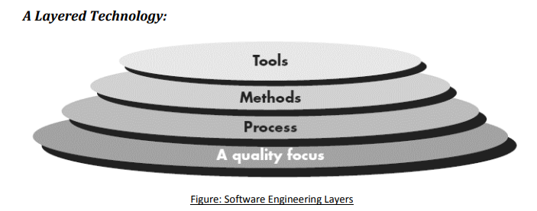

1. Quality Focus (Foundation)

Meaning: Quality is the foundation (base) of Software Engineering.

Explanation:
- Every software company wants to develop high-quality software.
- Good quality means:
  - Fewer errors (bugs)
  - Better performance
  - Customer satisfaction
- The main goal of software engineering is to produce quality software.

2. Process

Meaning:A Process is a step-by-step plan for developing software.

Easy Explanation:
The process tells developers:
- What to do
- When to do it
- How to do it
It helps in:
- Managing the project
- Completing work on time
- Maintaining software quality
- Handling changes properly

3. Methods
Methods are the technical techniques used to build software.

Easy Explanation:
Methods help developers perform different tasks such as:
- Communicating with customers
- Collecting requirements
- Designing software
- Writing code
- Testing the software
- Maintaining the software
Methods explain how to develop software correctly.

4. Tools

Meaning:
Tools are software applications that help developers do their work faster and more accurately.

Easy Explanation:
Tools help in:
- Writing code
- Designing software
- Testing programs
- Finding errors
- Managing projects
When many tools work together, they form a CASE (Computer-Aided Software Engineering) system.

Examples of Tools:
- Visual Studio
- Eclipse
- NetBeans
- Git
- JUnit
Tools make software development easier, faster, and more efficient.

Process & Generic Process Model
A software process is a set of activities, actions, and tasks that are performed to create a software product.
These activities, actions, and tasks are organized within a framework or model. The framework defines the order of the tasks and shows how they are connected to each other and to the overall software development process.

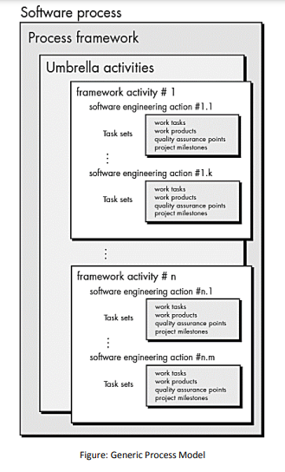

Generic Process Model
A software process is a series of steps used to develop a software product. It includes different activities, actions, and tasks that help in creating the software.
All these activities and tasks follow a framework or model. This framework shows what work should be done, in what order it should be done, and how each task is connected to the others.
Umbrella Activities:
A software engineering process includes umbrella activities, which are additional activities performed throughout the entire software project. These activities help the team manage the project, maintain quality, handle changes, and reduce risks.
This activity helps the software team monitor the project's progress. If the project is falling behind schedule, the team can take corrective actions to complete it on time.
Risk management identifies and analyzes problems that might affect the project or the quality of the software. It helps the team prepare solutions before problems occur.
Software Quality Assurance (SQA) ensures that the software meets the required quality standards. It checks whether the software is reliable, correct, and works properly.
Technical reviews examine the software and related documents to find and fix errors early. This s
Prescriptive Process Models
Prescriptive process models were originally proposed to bring order to the chaos of software development.
Traditional models have brought a certain amount of useful structure to software engineering work and have provided a reasonably effective road map for software teams.
Following are prescriptive process models:
̶ Waterfall model
̶ Incremental Model
- RAD Model
̶ Evolutionary Process Model
- Prototype Model
- Spiral Model
- Concurrent Process Model
Waterfall Process Model
The Waterfall Model is one of the oldest software development models. It follows a step-by-step process, where each phase is completed before moving to the next. The process starts with gathering customer requirements, then moves to planning, designing, coding, testing, deployment, and finally maintenance.

Limitations:
- Requirements should be clear and should not change during development.
- Each phase must be completed before starting the next phase.
- It cannot easily handle changing requirements.
- Customers cannot use the software until it is completely finished.
- After development, only maintenance is expected.
- Errors found at the end are costly and difficult to fix.
- Some team members may have to wait until the previous phase is completed.
- It is suitable only when requirements are well understood and changes are very few.

When to Use the Waterfall Model?
- Requirements are clear, fixed, and well understood.
- The product definition is stable.
- The technology to be used is well known.
- There are no unclear or changing requirements.
- Skilled team members and enough resources are available.
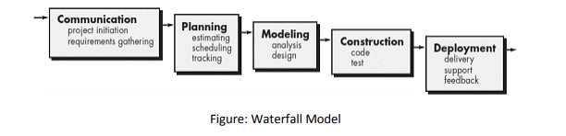
Incremental Process Model
The Incremental Model develops software step by step. Instead of building the entire software at once, it is divided into small parts called increments. Each increment adds new features to the software. The first version provides basic functions, and later versions add more advanced features until the software is complete.

Advantages:
- Working software is delivered quickly and early.
- It is easy to make changes to requirements.
- Testing and debugging are easier because each increment is small.
- Customers can give feedback after each increment.
- The initial delivery cost is lower.
- Risks are easier to identify and manage during each increment.

Disadvantages:
- Requires good planning and design.
- The complete system should be clearly understood before dividing it into increments.
- The total development cost may be higher than the Waterfall Model.

When to Use the Incremental Model?
- When the overall system requirements are clear and well understood.
- When major requirements are known, but some details can change over time.
- When the product needs to be released to the market quickly.
- When a new technology is being used.
- When skilled resources are limited.
- When the project has some high-risk features that need to be handled gradually.
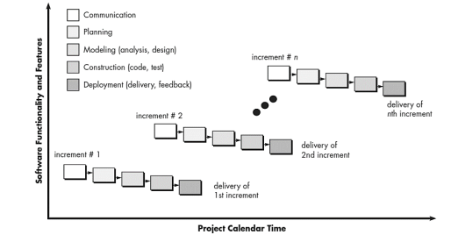
RAD (Rapid Application Development) Process Model

Rapid Application Development (RAD) Model (Simple Explanation)
The Rapid Application Development (RAD) Model is a type of Incremental Model. In this model, different parts of the software are developed at the same time by different teams. These parts are quickly completed, tested, and combined to create a working software. Customers can use the early version and give feedback, which helps improve the final product.

Advantages:
- Reduces the overall development time.
- Software components can be reused.
- Early reviews help find problems quickly.
- Encourages regular customer feedback.

Disadvantages:
- Requires a large team of skilled developers for big projects.
- Both developers and customers must actively participate.
- It is difficult to use if the system cannot be divided into modules.
- Not suitable for projects with high technical risks or new technologies.

When to Use the RAD Model?
- When the software can be divided into small modules.
- When the project needs to be completed in a short time (about 2–3 months).
- When enough skilled developers and designers are available.
- When the budget is sufficient to support rapid development tools.
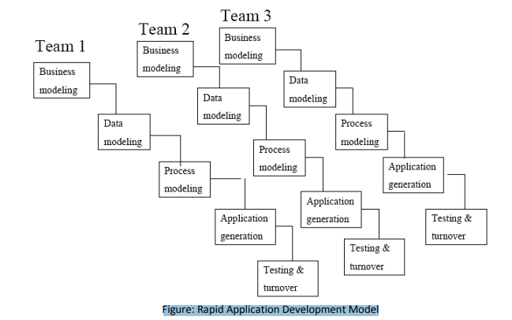
Prototype process model
The Prototype Model is used when the customer is not sure about the exact requirements. A sample or prototype of the software is first developed based on the available requirements. The customer uses this prototype, gives feedback, and the requirements are improved. The final software is then developed based on the updated requirements.

Advantages:
- Users are actively involved in the development process.
- Customers can better understand how the final system will work.
- Errors and problems are found early.
- Customer feedback is received quickly.
- Difficult or confusing functions can be improved.

Disadvantages:
- It may lead to frequent changes and rework.
- The project may become more complex if new requirements keep getting added.

When to Use the Prototype Model?
- When the customer is not sure about the requirements.
- When the system needs a lot of interaction with users.
- For web applications and online systems with user-friendly interfaces.
- When regular customer feedback is needed to improve the software.
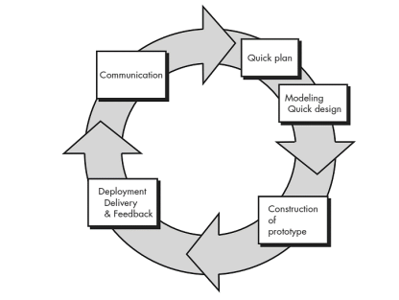

Spiral process model
The Spiral Model, proposed by Barry Boehm, is a software development model that combines the ideas of the Waterfall Model and Prototyping Model. It develops software in repeated cycles (spirals), where each cycle improves the system step by step. It focuses strongly on risk management and gradually builds a more complete version of the software.

Advantages:
- Helps in identifying and reducing risks early in the project.
- Suitable for large and critical projects.
- Provides strong control through documentation and approvals.
- New features can be added in later stages.

Disadvantages:
- It is expensive compared to other models.
- Requires experts for proper risk analysis.
- Not suitable for small projects.

When to Use the Spiral Model?
- When risk analysis is very important in the project.
- When the project is large or high-risk.
- When requirements are not clear or keep changing.
- When users are unsure about their exact needs.
- When developing a new or complex product.
- When major changes are expected during development.

Agile Process Model

Agile Model (Simple Explanation)
The Agile SDLC Model is a combination of iterative and incremental development. In this model, the software is developed in small parts (iterations). Each part goes through planning, requirements, design, coding, testing, and delivery. Agile focuses on flexibility, teamwork, and customer satisfaction by delivering working software quickly and continuously.

Advantages:
- Customers get working software quickly and regularly.
- Continuous communication between customers, developers, and testers.
- Focus on good design and technical quality.
- Easy to adapt to changes at any time.
- Even late changes in requirements are accepted.

Disadvantages:
- It is difficult to estimate time and cost at the beginning.
- Less focus on documentation and formal design.
- Requires highly skilled and experienced developers.

